SPRINT 1

|  |  |
| --- | --- |
| TEAM ID | PNT2022TMID44629 |
| PROJECT NAME | GAS LEAKAGE MONITORING AND ALERTING SYSTEM |

ARDUINO UNO WITH SENSOR:

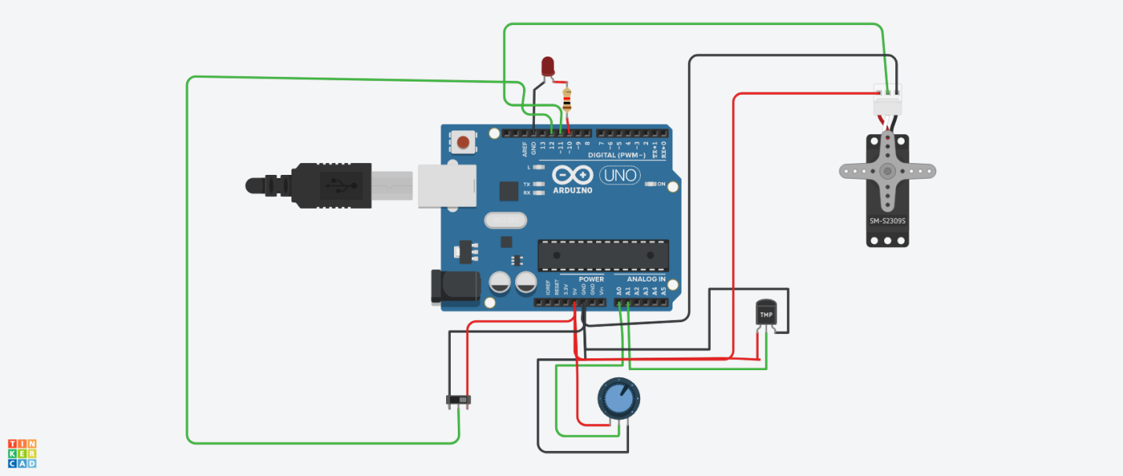

IN THE ABOVE CIRCUIT WE CONNECT THE ARDUINO UNO WITH SENSORS, BUZZER.

PROGRAM:

#include int reading=0;

Servo servo_11;

void setup() { pinMode(12,INPUT);

pinMode(A0,INPUT);

pinMode(10,OUTPUT);

servo_11.attach(11);

pinMode(A1,INPUT);

}

void loop()

{

if (digitalRead(12)==0) {

reading=analogRead(A0);

analogWrite(10,(reading*0.18));

servo_11.write((reading*0.25));

} else {

reading=analogRead(A1);

analogWrite(10,(reading*0.75-15.09));

servo_11.write((reading*0.53-10.65));

}

}